19. January 2017

Merivaara Q-Flow Surgical light wins Fennia Grand Prix in design
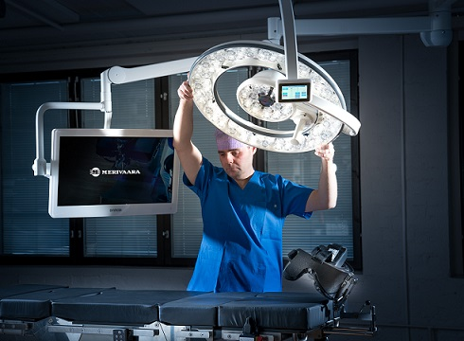
The new Q-Flow surgical light by Merivaara has won the prestigious Fennia Prize Grand Prix for industrial design. The Q-Flow is a revolutionary new operating room light created to reduce the risk of hospital infections and improve work ergonomics for hospital staff. Winning the award emphasizes the importance of functional design in the strong Finnish health tech sector.
“We are proud of the complete design of the Q-Flow, the combined aesthetics and functionality,” says Merivaara’s R&D Director Jyrki Nieminen. “We have a really great story to tell with the Q-Flow.”
The Fennia Prize is a biennial competition to award the best designs in products, services, business processes or concepts. The goal of the competition is to promote the use of design in business and society to enhance growth, competitiveness and internationalisation. It is organised by Design Forum Finland, Fennia, Elo and the Finnish Patent and Registration Office.
The jury praised the Q-Flow as a bold solution in a competitive global market. They point out that the lamp includes a number of innovations which can improve operating room hygiene as well as enhance the work of hospital staff. The lamp combines high technology, design and clear benefits to the user.

Standard operating room lights create turbulence above the operating area, pulling particles upwards right over the patient and possibly into the surgery area. Merivaara’s Q-Flow is shaped as a series of concentric circles with open spaces in between. This minimalistic design improves laminar air flow so sterile conditions are maintained.
“We performed a great deal of analysis with computer simulations and 3D models to understand what was happening,” Nieminen continues. “We determined this doughnut shape was an optimal solution.”
The Q-Flow was completely designed in Finland. Merivaara cooperated with Seos Design to develop the Q-Flow, as well as several other Finnish companies. Among others, Halton Group supported the aerodynamics design work.
Other innovations in the Q-Flow include superb colour rendering of skin and red hues, dynamic obstacle compensation and intuitive controls which project instructions onto the operating table so the surgeon doesn’t have to look up from the patient.
“Winning the Fennia Grand Prix shows we have the self-confidence to be a leader in the industry,” says Nieminen. “Now I hope surgical experts will understand the current situation with hygiene in operating rooms. This is a new discovery they might not be aware of. The best award we could receive would be if the Q-Flow decreases infections in operating rooms.”

About Merivaara
Merivaara focuses on offering solutions for operating rooms, surgical departments and recovery. Additionally, Merivaara provides a wide range of other furnishing solutions for hospitals, day surgery and health clinics. Established in 1901, Merivaara has more than 115 years of experience in designing and manufacturing hospital-grade equipment.
The user experience of our customers and uncompromised quality are at the heart of Merivaara’s company culture. Merivaara’s products are used in more than 120 countries thanks to their ease of use, durability and ergonomic design.
www.merivaara.com

